PANGANI GIRLS’ HIGH SCHOOL
POST MOCK 2019
Kenya Certificate of Secondary Education (KCSE)
September 2019
232/3
Marking scheme

QUESTION 1
PART A
H cm | Trial 1 | Trial 2 | Mean time t(s)
70 | 0 | 0 | 0
65 | 27 | 28 | 27.5
60 | 56 | 57 | 56.5
55 | 87 | 86 | 86.5
50 | 122 | 124 | 123.0
45 | 163 | 168 | 165.5
40 | 206 | 212 | 209.0
35 | 256 | 272 | 264.0
1 mark each row

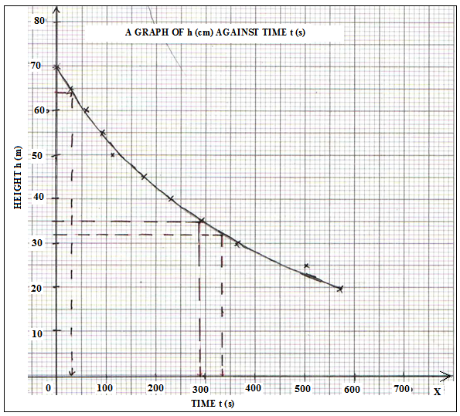

d) h=64cm; t=30.0s¹
h=42cm; t=210.0s¹
Time taken= 210 - 30= 180s ¹
e) From the graph when h=35cm; t=290s
gradient = 32-52 ¹
300-100
= -20/200 ¹
=-0.1cms⁻¹ ¹
QUESTION 2
PART A
- t₁ = 28.44s +/- 3s
t₂ = 29.50 s +/- 3s
t_{ave} = 28.97 s
- 20 oscillations = 28.97S
1 oscillation =?
= 1.448S
Period = T = 1.448s
- f = 1/T
=1/1.448
=0.6906 Hz
- T²=1.448²
=2.097 s²
- L = 50 cm = 0.5 m
- T²/L = 1.448²/0.5
=4.193s²m⁻¹

- 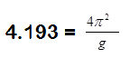
g= 9.418N/kg ¹

PART B

(i) U= 36.0 cm (1 mk)
(ii) U = 70.0 cm (1 mk)
(iii) d²=70.0 – 36.0 = 34.0 cm (1 mk)
(iv) (1 mk)
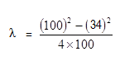

= 22.11 cm (1 mk)
v) f=20.0cm +/-2cm (1mk)
vi) λ = f , the focal length of the lens (1mk)

